Ayesha Jones  GB & NI Athlete  England Athlete  Youth Commonwealth Athlete  MMKAC Athlete | 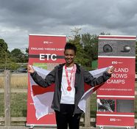

Introduction:
My name is Ayesha Jones. I am 16 years old and currently compete in the U17 age group. I am affiliated to Marshall Milton Keynes Athletic Club (MMKAC) and have been representing the club at competitions for the last 8 years. In the last couple of years, I have worked very hard to be at the top of my event and to be recognised as an elite athlete. Last year I became a GB & NI athlete and an England Athlete after being selected by Team GB and Team England to represent them.
Michael Phelps once said ‘You dream. You plan. You reach. There will be obstacles. There will be mistakes. But with hard work, with belief, with confidence and trust in yourself and those around you, there are no limits’. I believe every word of this. I believe anything you want in life is possible, some things may take time, but with hard work I can achieve my dreams.
My dream is to try and get to the Olympics, but I would also be honoured to represent my country in all the big championships like the Commonwealth Games and World Championships.
I have been lucky enough to represent GB & NI in the U18 European Championships in Jerusalem in 2022 and I have recently learnt that I have been selected for the Youth Commonwealth Games, which are being held in Trinidad and Tobago in August. This is also a competition that many GB and England athletes (for example, Dina Asher-Smith, Jessica Ennis-Hill) have taken part in who have gone on to represent the Country in bigger competitions.
In my spare time I enjoy watching all sports. I also volunteer to help at the clubs Star Track which is a programme run by one of my very first coaches at the club during school holiday’s and is a programme to allow the Under 11’s to participate in athletics. I help by working with some of the younger athletes and support and encourage them while they take part in the multi events.
I believe in giving back to the club and before I started my GCSE’s I use to volunteer on a Monday night to help at the U11 session. I would not be where I am today without the support and encouragement from the athletics club and for that I am very grateful of their continued support in my journey.

My Athletic Journey:
After a really successful sports day in Year 2 at First School, a PE teacher approached my mum and recommended I was taken along to the local athletics club and as they say the rest is history.
I initially started in the youngest group being taught multi events before moving into the U11 group. This was a great way to see which events I liked doing and is a great base to any athlete’s career in the sport. In fact, one of the coaches at my athletic club often says ‘the skills and discipline you learn through athletics can take you far in many sports’.
I continued to do multi events in the U13 age group. This was mainly at local open meetings before moving onto representing the club in the YDL (Youth Development League) as well as competing in National and Regional competitions. When I was 11 and in the U13 age group I competed in an open event at Milton Keynes and threw a javelin for the first time. My first recorded throw on the power of 10 is 23.06m.
After this competition, I realised that I enjoyed throwing the javelin and was keen to learn how to throw one properly. It was after this competition that I started going to Javelin training 2-3 times a week with the MMKAC’s javelin coach Janina Pownall. For the next 2 years I trained a few times a week and competed in multi events.
2020: When I moved into the U15 age group I started to want to concentrate on Javelin and although I competed in other disciplines for my athletics club, javelin was my main priority. Due to the pandemic in 2020, I only managed to compete in 4 competitions and the main championships were cancelled as it was in nearly all sports. The track was also closed for a large part of the year which meant training was also cancelled. We did do some home sessions that my coach put together for all the athletes she trains.
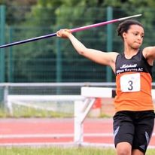
2021: In 2021 when I was a year 2 U15 athlete, training and competitions were almost back to normal. I participated in 18 competitions (12 were for javelin) and I was unbeaten in all but one competition.
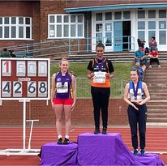
2022: When I moved into the U17 age group in 2022 I had made the decision that Javelin was the discipline in athletics that I wanted to be my main focus. Again, I have competed in other disciplines for the club, but Javelin is where my heart is.
2022 was a big year for me. It was the year I first threw over 50m!!! It was also the year I was unbeaten nationally and the year I was given the opportunity to represent Great Britian and Northern Ireland in the U18 European Championships which was held in Jerusalem. This was an amazing opportunity and one that I really enjoyed participating in. I was also given the opportunity to represent England at Moulton in the England Throws Camp.
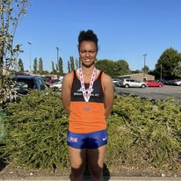
2023 (so far): This year has started off well, In February I was selected to represent England in the Växjö International in Sweden. It was an indoor competition and I came first.
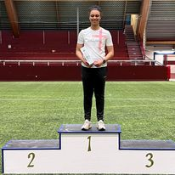
I was also selected to represent England in the Loughborough Throws Pathway International in May where I came 2nd.
Following my win at English Schools, I have been selected to represent England in the Home Countries’ International Schools’ Track and Field Championship which is being held in Grangemouth, Scotland. I am looking forward to competing against different athletes that I normally compete against.
I am proud that I have been selected for the Youth Commonwealth Games, which are being held in Trinidad and Tobago in August. The Standard to be considered was 48m and I have thrown this standard at multiple competitions this year within the qualifying period. This will be an amazing opportunity, not only to represent England, but also to compete against other javelin athletes from the Commonwealth Countries.

My Coach:
Since I have started Javelin training at MMKAC I have had the same coach, Janina Pownall. Janina has taught me so much and I am grateful for all that I have learnt and continue to learn from her. I also get some training and advice from her son Jonathon Pownall who also use to compete in Javelin.
The other coaches who helped me develop early on in the multi events are David Millet and Mick Lee.
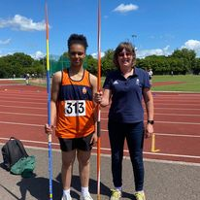

Achievements:
2023 Javelin Achievements U17 (2nd yr)
Ranked UK No.1 and all time No.3 on UK Rankings.
Ranked No.1 on U18 Commonwealth Games Rankings
June-23 English Schools (ESAA) Champion
June-23 Buckinghamshire Schools Champion
May-23 Buckinghamshire County Champion
May-23 Loughborough Throws Pathway England Participant
March-23 Växjö International U18 Champion
Feb-22 UK Winter Long Throws Champion

2022 Javelin Achievements U17 (1st yr)
Ranked UK No.1 and all time No.3 on UK Rankings.
Ranked No.2 on U18 Commonwealth Games Rankings
Sep-22 School Games Champion Sep-22 School Games Champion
Aug-22 National Championship Record 50.85m
Aug-22 National Champion (England Athletics)
Aug-22 South of England Championship Record 46.18m
Aug-22 South of England Outdoor Champion (SEAA)
Jul-22 European Athletics U18 Championships Participant
Jun-22 MMKAC Club Record 51.81m
Jun-22 Buckinghamshire Schools Champion
May-22 Buckinghamshire County Champion
2021 Javelin Achievements U15 (2nd yr)
Ranked UK No.1 and all time No.4
Aug-21 South of England Silver Medalist
Jul-22 English Schools (ESAA) Champion
Jul-21 Buckinghamshire County Champion
Jun-21 Buckinghamshire Schools Champion
2021 Other Achievements U15 (2nd yr)
Jun-21 Buckinghamshire Schools Champion - Shot
Jun-21 Buckinghamshire Schools Champion - Discus
2020 Javelin Achievements U15 (1st yr)
Ranked No.3
2019 Javelin Achievements U13 (2nd yr)
Ranked UK No.2 and all time No.3.
Jun-19 Buckinghamshire Schools Champion
May-19 Buckinghamshire County Champion

